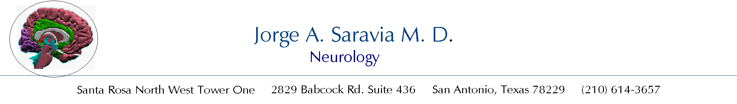
ORDERS FOR SPINAL TAP AND CSF ANALYSIS.

Patient Name_________________________________________ Date___________________

=YES = NO

□1. Obtain a signed permit for Spinal Tap.
□2. Measure opening pressure in lateral decubitus.

3. After Spinal tap send CSF for:
Tube 1.
□ Cell count with differential, Glucose, Protein.
Tube 2.
□ Bacterial Cultures and sensitivity, CIE, Gram Stain.
□ Fungal Cultures to include AFB.
□ Viral Cultures: Human Herpes 6, CMV. JC, Varicella Zoster.
□ Antigens: Cryptococcal and histoplasma polysaccharide.
□ Antibodies: West Nile, Toxoplasma Gondii
□ Antibodies: Anti-HSV, Anti Varicella-Zoster
□ Coccidioides immitis complement fixation.
□ PCR: HSV-1, HSV-2, Varicella-Zoster, CMV, JC, EB,
□ India ink.
Tube 3.
□ Immunoglobulins, Oligoclonal Banding, Basic Myelin Protein.
□ Flow cytometry.
□ Cytology.
Tube 4.
□ Freeze and save for 2 weeks.
□3. Bed rest without pillow after the procedure.

Jorge A. Saravia MD.

AFB = Acid Fast Bacillus
HSV = Herpes Simplex Virus.
PCR = Polymerase Chain Reaction.
JC = Jakob-Creutzfeldt.
EB = Epstein Barr.

